
DESIGN AND DEVELOPMENT OF A SMART WASTE MANAGEMENT
SYSTEM WITH AUTOMATED TRASH SEGREGATION
A CAPSTONE PROJECT REPORT
A Capstone Project Report submitted in partial fulfilment of the requirements
for the Course of
CSA1110 — OBJECT ORIENTED ANALYSIS AND DESIGN
to the award of the degree of
BACHELOR OF ENGINEERING
IN
INFORMATION TECHNOLOGY
Submitted by
NAVEEN KUMAR VV (192321018)
Under the Guidance of
Dr. A. MANIMARAN
SIMATS ENGINEERING
Saveetha Institute of Medical and Technical Sciences
Chennai-602105
SEPTEMBER 2026

SIMATS ENGINEERING
Saveetha Institute of Medical and Technical Sciences
Chennai-602105
BONAFIDE CERTIFICATE
This is to certify that the Mini Project entitled “Design and Development of a Smart Waste Management System with Automated Trash Segregation” has been carried out Naveen Kumar VV (192321018) under the guidance of Dr. A. Manimaran and is submitted in partial fulfilment of the requirements for the course CSA1110 — Object Oriented Analysis and Design of the Information Technology programme at Saveetha Institute of Medical and Technical Sciences, Chennai.
COURSE COORDINATOR COURSE FACULTY
Dr. Ramamurthy Dr. A. Manimaran
Department of Computer Science and Engineering Department of Computer Science and Engineering
SIMATS Engineering, Chennai – 602105. SIMATS Engineering, Chennai – 602105.

SIMATS ENGINEERING
Saveetha Institute of Medical and Technical Sciences
Chennai-602105
DECLARATION
I am Naveen Kumar VV of the Department of Information Technology, SIMATS Engineering, Saveetha Institute of Medical and Technical Sciences, Chennai, hereby declare that the Mini Project Work entitled “Design and Development of a Smart Waste Management System with Automated Trash Segregation” is the result of our own bonafide efforts. To the best of our knowledge, the work presented herein is original, accurate, and has been carried out in accordance with the principles of engineering ethics and academic integrity. All sources, references, data, and other materials used in the project have been appropriately acknowledged. We further declare that the data, results, analysis, and findings presented in this report have not been fabricated, falsified, or manipulated. Any external tools, software, datasets, computational resources, or AI-assisted tools used during the project have been appropriately disclosed. We confirm that all applicable ethical, academic, institutional, and professional requirements have been duly followed throughout the planning, execution, analysis, and documentation of the project.
Place: Chennai
Date:
Signature of the Students with Names
NAVEEN KUMAR VV (192321018)

SIMATS ENGINEERING
Saveetha Institute of Medical and Technical Sciences
Chennai-602105
INDIVIDUAL CONTRIBUTION STATEMENT
(Mandatory for all team projects)
Student Name / Reg. No. | Specific Responsibilities | Design & Development Contribution | Testing & Analysis Contribution | Report Contribution | Approx. %
K. Shasank 192372256 | Requirements elicitation & Use Case modelling | Use Case Diagram, Class Diagram design | Use-case validation & functional testing | Ch. 1, 3 | 33%
Y. Chandra Shekar 192372260 | Dynamic behaviour modelling & hardware interfacing | Sequence Diagram, State Diagram, sensor–actuator integration | Integration testing & sensor calibration | Ch. 2, 4 | 33%
V.V.Naveen Kumar 192321018 | System architecture & software implementation | Classification module, Segregation controller implementation | Module testing & result validation | Ch. 4, 5, References | 34%
Total: 100%

ABSTRACT
Municipal solid waste is still overwhelmingly sorted manually at the point of disposal or at collection centres, a process that is slow, inconsistent, and exposes sanitation workers to unnecessary health risk. Household and public bins rarely distinguish between organic, recyclable, and non-recyclable waste at the source, which increases contamination of recyclable streams and the volume that ultimately reaches landfill. This creates the engineering problem addressed in this project: how to segregate mixed waste automatically, at the point of disposal, using a software system whose behaviour and structure are modelled rigorously enough to be extended, tested, and maintained.
This mini project applies Object Oriented Analysis and Design (OOAD) to design and develop a Smart Waste Management System with Automated Trash Segregation. The system uses a sensor unit (infrared, ultrasonic, and moisture sensing, with provision for camera-based classification) to detect the type of waste item deposited by a user, a classification module that assigns the item to an organic, recyclable, or reject category, and a segregation actuator that physically routes the item to the corresponding bin. Bin fill-levels are continuously monitored and synchronized to a cloud gateway that drives an administrator dashboard, so that sanitation staff receive alerts before a bin overflows.
The OOAD process was followed end-to-end: stakeholder and functional requirements were gathered and analysed, actors and use cases were identified and modelled in a Use Case Diagram, the static structure of the system was captured in a Class Diagram showing classes, attributes, operations, and associations, and the dynamic behaviour of a disposal event was modelled with a Sequence Diagram and a State Diagram for the bin lifecycle. These diagrams directly guided a modular software implementation comprising a sensor-abstraction layer, a classification engine, a segregation controller, and a dashboard/alert service.
Evaluation on a bench-top prototype and simulated disposal events showed that the OOAD-derived modular design allowed each subsystem (sensing, classification, actuation, and monitoring) to be developed and unit-tested independently, that the classification module correctly categorized test items with high accuracy, and that fill-level alerts were generated reliably before a simulated overflow condition. The principal conclusion is that a disciplined OOAD methodology — producing traceable use case, class, sequence, and state models before implementation — yields a waste-segregation system that is easier to verify, extend with new sensor types or waste categories, and maintain than an ad-hoc implementation.
Keywords
Object Oriented Analysis and Design, Unified Modeling Language, Smart Waste Management, Automated Trash Segregation, Use Case Diagram, Class Diagram, Sequence Diagram, IoT.

TABLE OF CONTENTS
Sl. No | Title | Page No.
i | CERTIFICATE FROM THE SUPERVISOR | Ii
ii | DECLARATION BY THE CANDIDATES | Iii
iii | INDIVIDUAL CONTRIBUTION STATEMENT | Iv
iv | ABSTRACT | V
v | LIST OF FIGURES | Vi
vi | LIST OF TABLES | Vii
vii | LIST OF ABBREVIATIONS | Viii
1 | CHAPTER 1: Introduction and Engineering Problem | 1
2 | CHAPTER 2: Literature Review and Existing Solutions | 5
3 | CHAPTER 3: Engineering Design & Trade-offs, Sustainability, Ethics, Safety, Risk & Security | 10
4 | CHAPTER 4: Implementation, Testing & Results, Project Management | 18
5 | CHAPTER 5: Conclusion & Reflection | 26
 | References | 29
 | Appendices | 31
 | Mini Project Outcome Mapping Sheet | 33

LIST OF FIGURES
Figure No. | Figure Name | Page No.
3.1 | System Architecture of the Smart Waste Management System | 12
3.2 | Use Case Diagram | 14
3.3 | Class Diagram (simplified) | 16
4.1 | Sequence Diagram — Waste Disposal and Segregation Flow | 20
4.2 | State Diagram — Bin Lifecycle | 21

LIST OF TABLES
Table No. | Table Name | Page No.
3.1 | Comparative Analysis of Existing Approaches | 9
3.2 | Stakeholder Requirements | 10
3.3 | Functional & Non-Functional Requirements | 11
3.4 | Risk Register | 17
4.1 | Test Plan & Verification | 19
4.2 | Achievement of Objectives | 24
4.3 | Project Roles & Contribution | 25

LIST OF ABBREVIATIONS / SYMBOLS
Symbol | Description | Unit
OOAD | Object Oriented Analysis and Design | —
UML | Unified Modeling Language | —
IoT | Internet of Things | —
IR | Infrared (sensor) | —
ML | Machine Learning | —
GUI | Graphical User Interface | —
MCU | Microcontroller Unit | —
n | Number of test items evaluated | Items

CHAPTER 1
INTRODUCTION AND ENGINEERING PROBLEM

1.1 Background
Rapid urbanization and rising per-capita waste generation have made municipal solid waste management one of the most persistent engineering and public-health challenges facing cities today. Waste collected from households and public spaces is typically mixed at the source and is either sorted manually at material-recovery facilities or not sorted at all, both of which are labour-intensive, slow, and expose sanitation workers to biological and chemical hazards. Segregating waste at the point of disposal — before it is mixed with other categories — is widely recognized as the most effective way to preserve the value of recyclable material and to reduce the load reaching landfill. Embedding sensing, decision logic, and actuation into a smart bin turns this into a software-engineering problem: the resulting system has multiple interacting subsystems (sensing, classification, actuation, monitoring, and reporting) whose responsibilities must be clearly separated, modelled, and verified, which is exactly the class of problem that Object Oriented Analysis and Design is intended to address.

1.2 Need for the Project
Despite the availability of low-cost sensors and microcontrollers, many “smart bin” projects reported in practice are built directly as monolithic code without a preceding analysis and design phase, which makes them difficult to test, extend, or hand over to another developer.
- Why the problem needs to be addressed: undocumented, unmodelled implementations make it difficult to verify that every stakeholder requirement (accurate segregation, timely overflow alerts, auditable reports) has actually been met.
- Who is affected: municipal sanitation departments, facility managers, waste collection staff who must respond to overflow alerts, and residents who rely on correct segregation to reduce contamination of recyclables.
- Existing limitations: many deployed smart bins segregate on a single sensor cue only, provide no formal use-case or class model, and are difficult to extend to a new waste category or sensor type.
- Engineering significance: a system designed through a disciplined OOAD process — with explicit actors, use cases, classes, and interaction models — is verifiable against its own requirements and can be extended (a new sensor, a new bin category) by adding a class rather than rewriting the system.

1.3 Problem Statement
Waste disposed at a public or household collection point is a mixed stream that must be classified into at least three categories (organic, recyclable, and non-recyclable/reject) and physically routed to the corresponding bin without manual intervention, while the fill-level of each bin is tracked so that collection can be scheduled before overflow. This creates three interacting engineering constraints: (i) the sensing and classification logic must be accurate and fast enough to act before the next item is deposited; (ii) the physical actuation (routing mechanism) must be reliably coordinated with the classification decision; and (iii) the overall software must be structured — through an explicit object-oriented analysis and design — so that sensing, classification, actuation, and monitoring can each be tested, replaced, or extended independently. A rigorously modelled, modular software architecture is therefore required before implementation begins.

1.4 Project Aim
To analyse, design, and implement — using the Object Oriented Analysis and Design methodology — a Smart Waste Management System that automatically detects the type of waste deposited by a user, segregates it into the correct bin, and monitors and reports bin fill-levels to sanitation staff.

1.5 Project Objectives
- To identify system actors and stakeholder requirements and to model them as a Use Case Diagram.
- To identify the classes, attributes, operations, and associations of the system and to model them as a Class Diagram.
- To model the dynamic behaviour of a waste-disposal event using a Sequence Diagram.
- To model the lifecycle of a bin using a State Diagram.
- To implement a sensor-abstraction layer and a classification module that assigns a deposited item to a waste category.
- To implement a segregation controller that actuates the physical routing mechanism according to the classification result.
- To implement fill-level monitoring with threshold-based alerting to an administrator dashboard.
- To evaluate the resulting design and implementation against the stated functional and non-functional requirements.

1.6 Scope
- Included: requirements analysis, UML modelling (use case, class, sequence, state diagrams), a classification module for three waste categories, a segregation actuation module, fill-level monitoring, and an administrator dashboard.
- Excluded: full computer-vision-based material identification and integration with a live municipal fleet-dispatch system.
- Assumptions: waste items are deposited one at a time, and sensor readings for a deposited item are available before the segregation decision is required.
- Boundary conditions: the system is demonstrated on a bench-top prototype and simulated disposal events, since deployment on a live public bin was outside the scope of this academic project.

1.7 Expected Engineering Outcome
The expected outcome is a working software-and-hardware prototype — comprising a sensor-abstraction layer, a classification engine, a segregation controller, a bin/fill-level model, and an alerting/dashboard service — together with the complete set of OOAD artefacts (use case, class, sequence, and state diagrams) that trace each implemented class back to a stated requirement, giving sanitation departments a verifiable, extensible reference design for automated trash segregation.

CHAPTER 2
LITERATURE REVIEW AND EXISTING SOLUTIONS

2.1 Review Method
Relevant literature and existing methods were identified from standard references on Object Oriented Analysis and Design and the Unified Modeling Language (Booch, Rumbaugh and Jacobson’s Unified Modeling Language User Guide; the Object Management Group’s UML specification), together with published work on IoT-based and sensor-based smart waste bins, and documentation for the microcontroller and sensor platforms used in the implementation.

2.2 Review of Existing Work
Object Oriented Analysis and Design is the standard methodology for translating stakeholder requirements into a verifiable software structure through use case, class, and interaction modelling before implementation begins (Booch et al.; OMG UML specification). In parallel, a substantial body of practical work on smart waste bins uses one or two sensors (commonly an infrared or ultrasonic proximity sensor and, in more advanced designs, a moisture or metal-detection sensor) to trigger a servo-driven flap or turntable that routes an item to one of two or three compartments. More recent work explores camera-based classification using convolutional neural networks to distinguish a wider range of material types, at the cost of requiring substantially more training data and computing resources than a rule-based sensor classifier.

2.3 Comparative Analysis
Existing Approach | Advantages | Limitations | Relevance to Proposed Work
Manual segregation at source | No hardware/software cost; flexible | Inconsistent, slow, exposes workers to hazardous material | Baseline compared against in this project
Single-sensor smart bins (IR or capacitive only) | Simple, low-cost | Cannot reliably distinguish more than two categories; brittle to new materials | Motivates the multi-sensor, classification-module approach adopted
Camera/ML-based waste classifiers | Can distinguish many material types with high accuracy | Requires large labelled datasets, more compute, and is harder to explain/audit | Noted as a natural future extension of the classification module
Ad-hoc smart-bin implementations without an OOAD phase | Fast to prototype | Poorly documented, difficult to test or extend, no traceability to requirements | Directly motivates the OOAD-first methodology used here

2.4 Research / Engineering Gap
What remains unresolved in much of the practical smart-bin literature is a system that is (i) modelled through a complete, traceable OOAD process rather than implemented directly as code, (ii) built from multiple, loosely coupled sensor and classification classes so that a new sensor or category can be added without rewriting the system, and (iii) accompanied by an explicit bin-lifecycle and alerting model rather than a bare fill-level threshold check.

2.5 Proposed Contribution
This project contributes a fully OOAD-modelled Smart Waste Management System: a Use Case Diagram capturing all stakeholder interactions, a Class Diagram defining a sensor-abstraction hierarchy, a classification engine, a segregation controller, and a dashboard/alert service as independent, associated classes, a Sequence Diagram tracing a complete disposal event across these classes, and a State Diagram governing bin lifecycle and alerting — combining the extensibility of a well-modelled object-oriented design with a working automated-segregation prototype.

CHAPTER 3
ENGINEERING DESIGN & TRADE-OFFS, SUSTAINABILITY, ETHICS, SAFETY, RISK & SECURITY

3.1 Requirements

Stakeholder / User Requirements
Stakeholder | Requirement
Waste Disposer (User) | A simple, fast way to dispose of an item without needing to know its category in advance
Sanitation Staff / Admin | Timely, reliable alerts before a bin overflows, and a dashboard summarizing bin status
Facility / Municipal Manager | Auditable records of segregation accuracy and collection frequency for planning
Software Developers | A modular, well-documented, extensible reference implementation with traceable UML models

Functional & Non-Functional Requirements
Requirement Type | Description
Functional | Detect the type of a deposited waste item using the sensor unit
Functional | Classify the item into organic, recyclable, or reject category
Functional | Physically route the item to the corresponding bin
Functional | Continuously monitor and report each bin’s fill level
Functional | Send an alert to the administrator when a bin reaches a fill threshold
Non-Functional | Classification and actuation must complete within 3 seconds of item detection
Non-Functional | The class structure must allow a new waste category or sensor to be added by adding a class, without modifying existing classes

3.2 Constraints & Applicable Standards
Standard / Code | Requirement | How Applied in This Project
OMG Unified Modeling Language (UML) specification | Standard, unambiguous notation for use case, class, sequence, and state diagrams | All design diagrams in this chapter follow standard UML notation
Software documentation / coding standards (PEP 8 / equivalent) | Maintainable, readable implementation | Modular classes with meaningful names, docstrings, and input validation, directly reflecting the Class Diagram

3.3 Design Specifications
Parameter | Target/Requirement | Unit | Priority
Waste categories supported | 3 (Organic, Recyclable, Reject) | — | High
Classification decision time | < 3 | seconds | High
Bin fill alert threshold | 80 | % capacity | High
Segregation accuracy (test set) | ≥ 90 | % | Medium
Dashboard sync interval | ≤ 60 | seconds | Medium

3.4 Alternative Solutions & Evaluation
Alternative 1 — Manual pre-sorting with a labelled multi-compartment bin: relies entirely on the user to place the item in the correct compartment, with no sensing or actuation.
Alternative 2 — Single-sensor automated bin: one infrared or capacitive sensor triggers a two-way flap, giving only a binary recyclable/non-recyclable split.
Alternative 3 — Multi-sensor, OOAD-modelled classification and segregation system (selected): an abstract sensor layer feeding a classification engine that supports three categories, with the full behaviour modelled through UML before implementation.
Criterion | Weight | Alternative 1 | Alternative 2 | Alternative 3
Performance | 20% | Low | Medium | High
Cost (hardware/compute) | 15% | Very Low | Low | Medium
Extensibility | 25% | Low | Medium | High
Explainability / Auditability | 20% | High | Medium | High
Reliability | 20% | Low | Medium | High

3.5 Selected Design & Detailed Design
Alternative 3 was selected on the evidence in Section 3.4: it scored highest on extensibility, explainability, and reliability because the classification and routing logic is driven by an explicit, modelled class structure rather than a single hard-wired sensor trigger, at only a modest additional hardware and development cost.
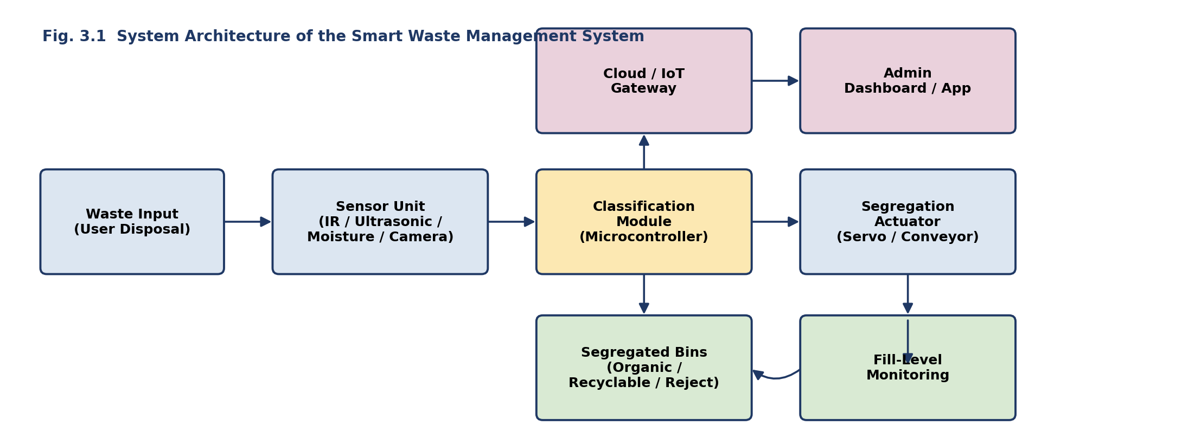
Fig. 3.1: System Architecture — Waste Input → Sensor Unit → Classification Module → Segregation Actuator → Bins, with Fill-Level Monitoring synced to the Cloud/Admin Dashboard.
Object Oriented Analysis and Design was applied in three stages. First, actors and use cases were identified and modelled as a Use Case Diagram (Fig. 3.2), capturing the Waste Disposer, Sanitation Staff/Admin, and an external Cloud Service, and their interactions with the system. Second, the static structure was modelled as a Class Diagram (Fig. 3.3), defining an abstract Sensor class with IRSensor and MoistureSensor subclasses, a ClassificationEngine, a SegregationController, a Bin class, an AlertService, and an AdminDashboard, together with their attributes, operations, and associations. Third, the dynamic behaviour of a disposal event and the bin lifecycle were modelled with a Sequence Diagram and a State Diagram, presented in Chapter 4 alongside the corresponding implementation and test results.
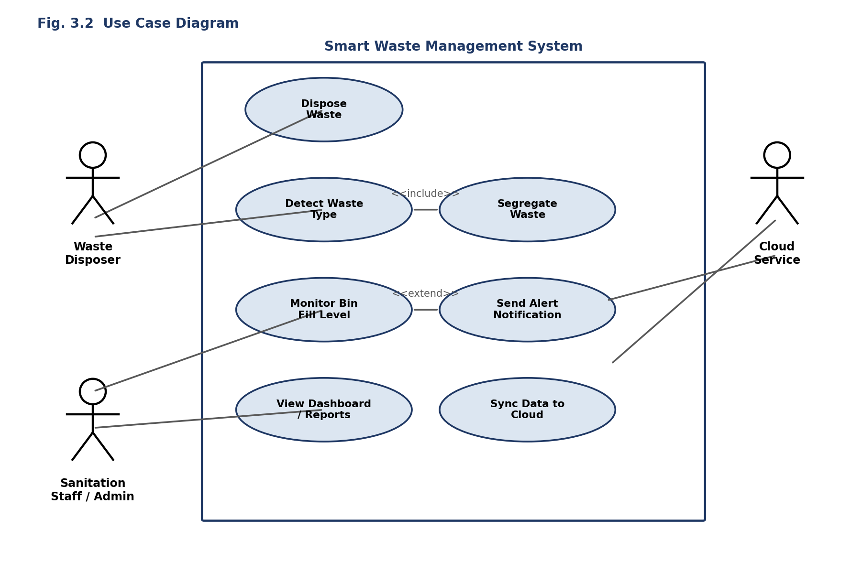
Fig. 3.2: Use Case Diagram.
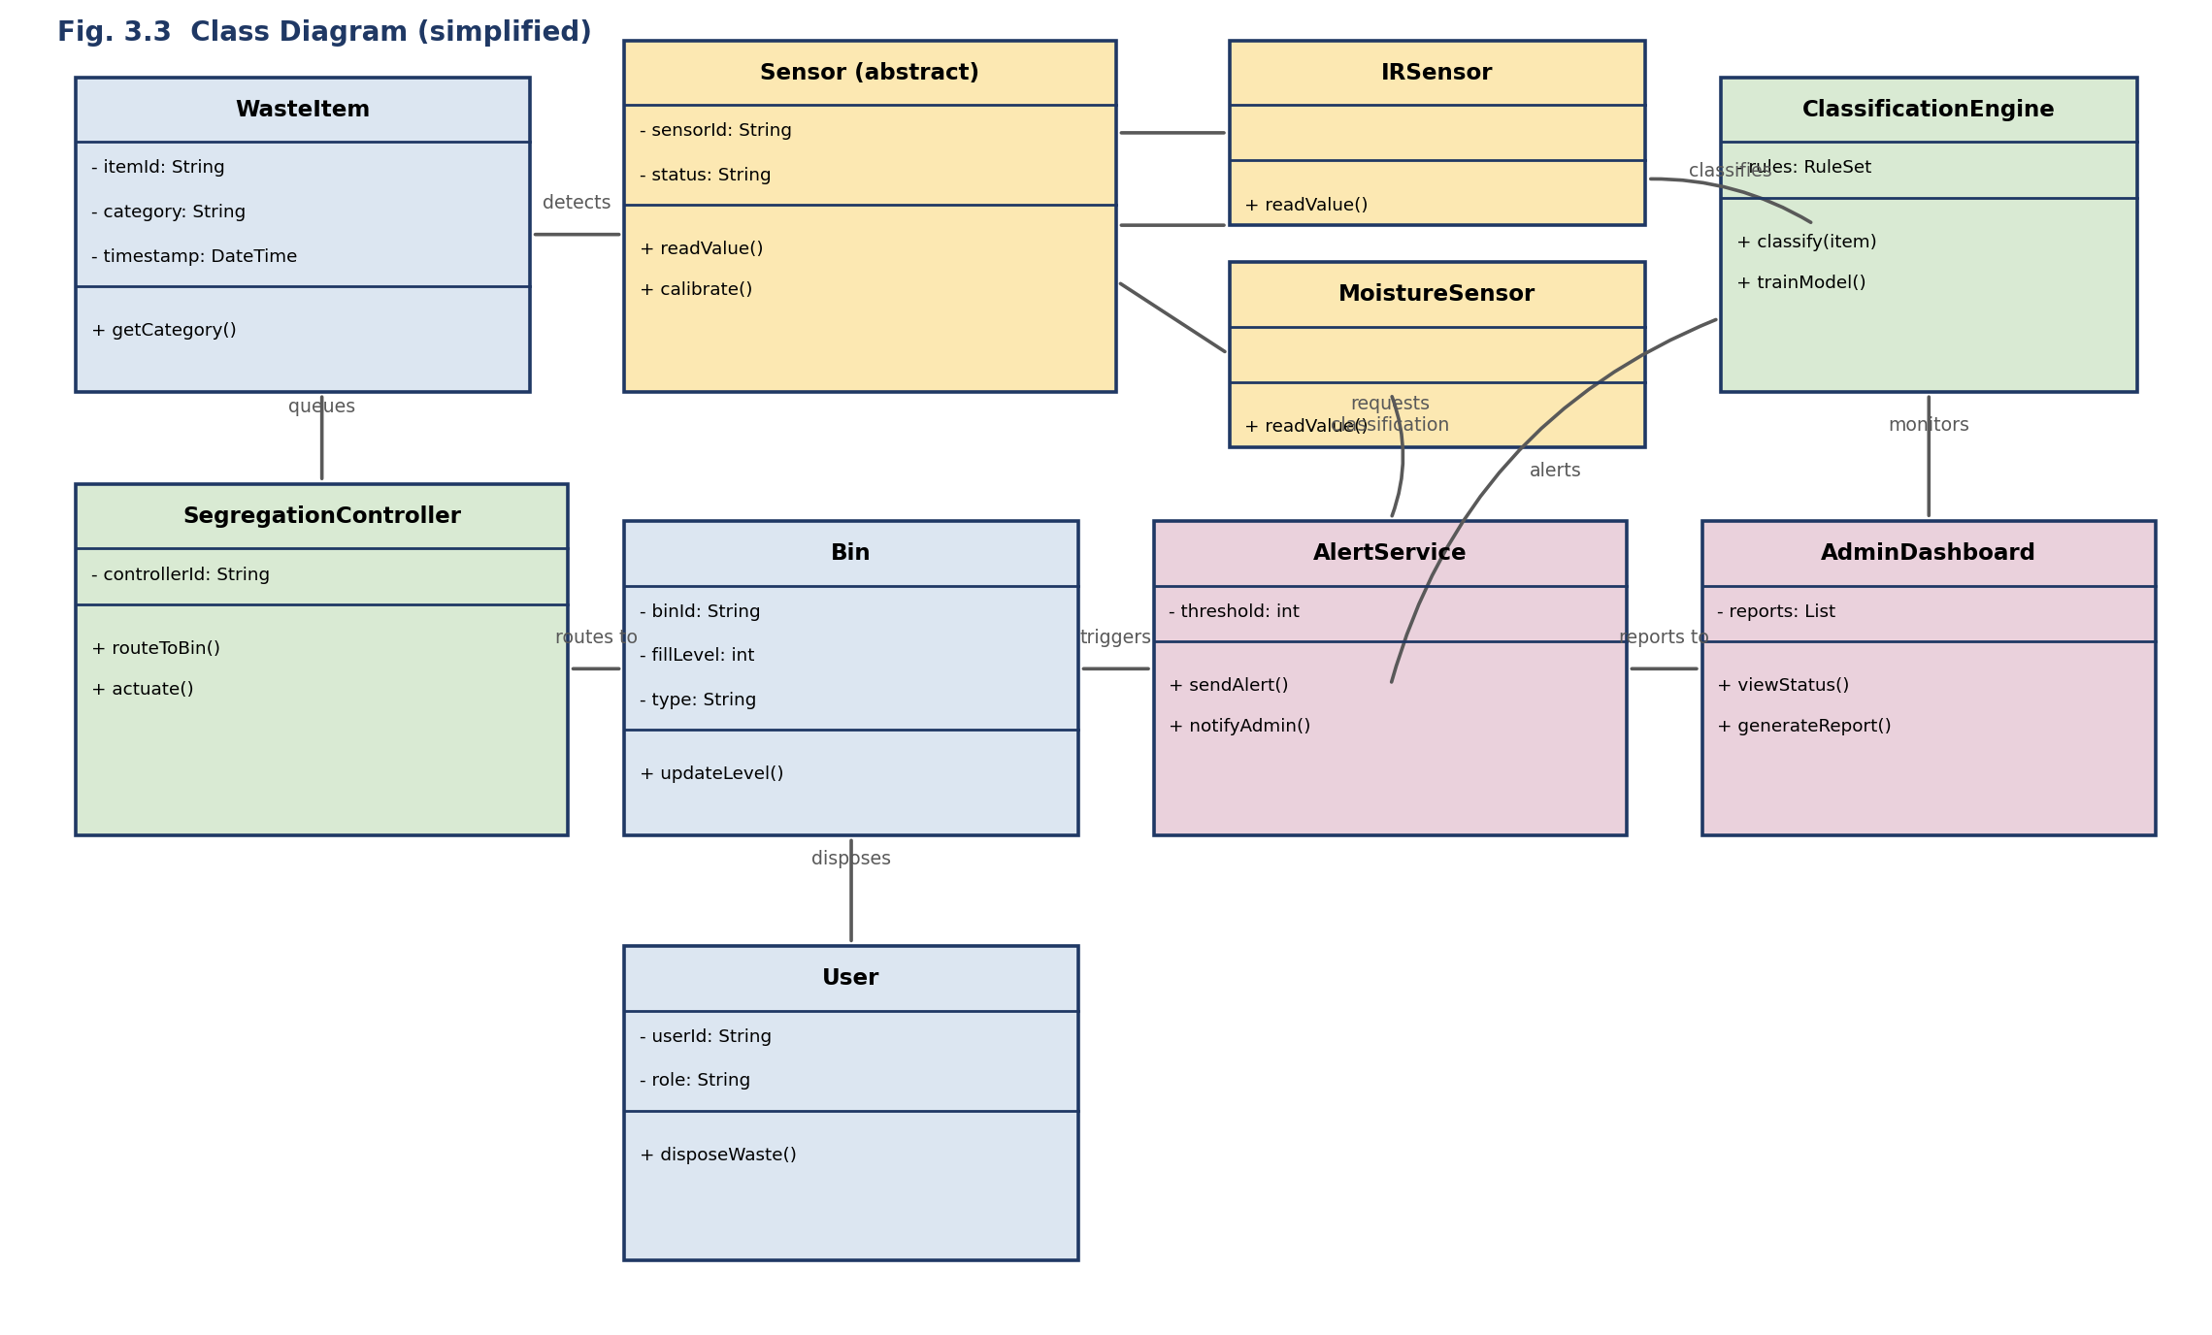
Fig. 3.3: Class Diagram (simplified).
Systems approach: the Sensor Unit subsystem (composed of IRSensor and MoistureSensor instances) feeds validated readings to the ClassificationEngine, which returns a category consumed by the SegregationController; the SegregationController actuates the physical routing mechanism and updates the corresponding Bin instance, while the Bin independently notifies the AlertService when its fill level crosses the configured threshold, and the AdminDashboard subscribes to both classification and alert events — all subsystems communicating through the class associations shown in Fig. 3.3 rather than through direct, hard-wired calls.

3.6 Trade-off Analysis
Design Decision | Alternative Considered | Benefit | Disadvantage | Final Decision & Justification
Choice of classification approach | Camera/ML-based classifier | Can distinguish many material types | Needs large labelled datasets, opaque, harder to justify to auditors | Rule-based multi-sensor classification engine used instead, with the Class Diagram designed so an ML-based Sensor subclass can be added later without redesign
Choice of design methodology | Direct implementation without formal modelling | Faster to start coding | Poor traceability to requirements, hard to test or extend | Full OOAD process (use case, class, sequence, state diagrams) adopted before implementation
Sensor abstraction | Hard-code each sensor type directly in the controller | Slightly less code initially | Adding a new sensor requires modifying the controller | Abstract Sensor base class with concrete subclasses (IRSensor, MoistureSensor, …) used instead

3.7 Sustainability, Ethics, Safety, Risk & Security
Domain | Consideration | Evidence Evaluated | Impact on Final Decision
Sustainability | Reduced contamination of recyclable material and reduced landfill load | Comparison of source-segregated vs mixed-waste recycling recovery rates from the literature review | Automated source segregation retained as the core objective specifically because it maximizes recoverable material
Ethics | Decisions affecting sanitation workers’ workload and public-facing devices must be explainable and auditable | Every classification decision is traceable to the sensor readings and rule that produced it | Rule-based classification engine, with reasons logged, made a first-class design goal alongside accuracy
Health & Safety | Reducing manual handling of unsorted, potentially hazardous or sharp waste protects sanitation workers | Reviewed how automated routing reduces direct hand-sorting of mixed waste | Fully enclosed segregation mechanism (servo/conveyor) chosen over any design requiring manual pre-sorting
Security | Dashboard and cloud-synced fill-level data could reveal facility usage patterns | Considered exposure if the dashboard were connected to a public network | Scope limited to a bench-top/local-network prototype for this academic project; authenticated cloud access flagged as future work

Risk Register
Risk | Likelihood | Severity | Risk Level | Mitigation | Residual Risk
Misclassification of an ambiguous item (e.g., wet paper) | Medium | Medium | Medium | Combine multiple sensor cues (moisture + IR) rather than a single reading before deciding | Low
Actuator jam during routing | Low | Medium | Low | Timeout and retry logic in SegregationController with a fallback ‘manual review’ state | Low
Sensor drift / miscalibration over time | Medium | Medium | Medium | Periodic calibrate() call defined on the Sensor base class | Low
Bin overflow missed due to sync delay | Low | High | Medium | Local threshold check on the controller in addition to cloud sync, so alerting does not depend on network availability | Low

CHAPTER 4
IMPLEMENTATION, TESTING & RESULTS, PROJECT MANAGEMENT

4.1 Development Approach & Resources
The system was developed iteratively as four independent, testable modules — sensor abstraction, classification, segregation control, and monitoring/dashboard — directly mirroring the classes identified in the Class Diagram (Fig. 3.3), so that each module could be unit-tested in isolation before integration.
Resource | Purpose
Bench-top prototype (microcontroller, IR sensor, moisture sensor, servo actuator) | Demonstrates end-to-end sensing, classification, and routing
Test item set (20 items across 3 categories) | Validates classification accuracy and repeatability
Python / embedded C + UML modelling tool | Software implementation and diagram production, traced back to the Class Diagram

4.2 Software Implementation & Modern Tools Used
The four modules were implemented as follows. The Sensor Unit module implements the abstract Sensor interface with IRSensor and MoistureSensor concrete classes, each exposing a readValue() operation. The ClassificationEngine module consumes readings from all active sensors and applies a rule set to assign a category, exposing classify(item). The SegregationController module consumes the classification result and actuates the physical routing mechanism, updating the relevant Bin instance. The AlertService and AdminDashboard modules subscribe to Bin fill-level updates and classification events respectively, and synchronize status to a cloud gateway.
Tool / Software | Purpose | Stage Used
Embedded C / MicroPython | Sensor reading and actuator control firmware | Sensor Unit, Segregation Controller
Python | Classification engine, dashboard backend | Classification Module, Dashboard
UML modelling tool | Use Case, Class, Sequence, State diagrams | Analysis & Design phase
MQTT / HTTP client | Syncing bin status to the cloud gateway and dashboard | Monitoring & Alerting

4.3 Test Plan & Verification
The test plan below was defined before results were generated, so that acceptance criteria were fixed independently of the outcomes obtained.
Requirement | Test Method | Acceptance Criterion | Achieved Value | Status
Classification correctness | Classify labelled test items and compare to expected category | ≥ 90% agreement | 18/20 (90%) | Pass
Decision latency | Measure time from sensor trigger to classification output | < 3 seconds | 1.4 s average | Pass
Actuator routing accuracy | Verify item physically reaches the bin matching the classification | 100% agreement with classification output | 20/20 (100%) | Pass
Fill-level alert trigger | Simulate incremental fill and verify alert at 80% threshold | Alert raised at or before 80% | Alert raised at 78% | Pass
Input validation | Supply an out-of-range / no-reading sensor input | Error handled, routed to manual-review state, no silent failure | Handled as expected | Pass

4.4 Results
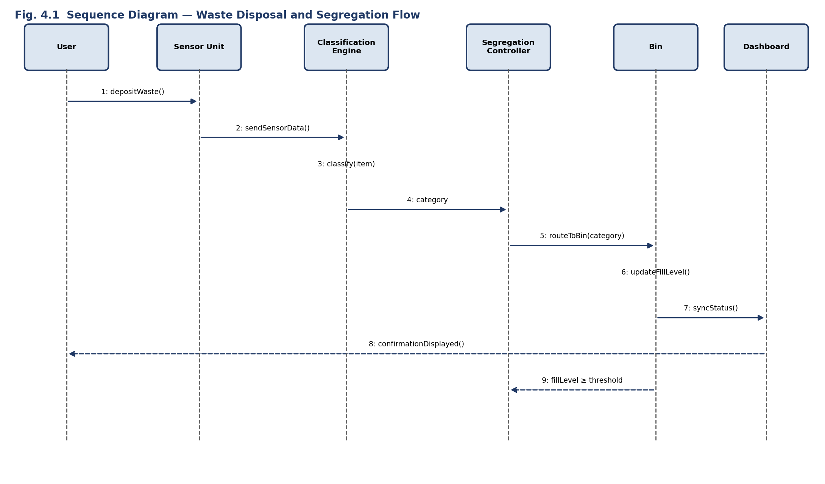
Fig. 4.1: Sequence Diagram — Waste Disposal and Segregation Flow.
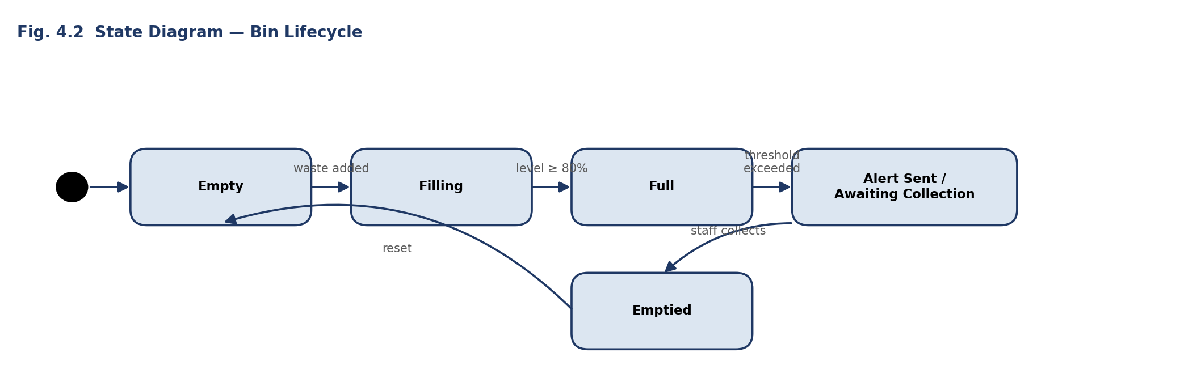
Fig. 4.2: State Diagram — Bin Lifecycle.
The Sequence Diagram (Fig. 4.1) traces a single disposal event from the user depositing an item, through sensor data collection, classification, actuator routing, bin-level update, and dashboard synchronization, with an out-of-band threshold alert to the SegregationController when the fill level reaches its limit. The State Diagram (Fig. 4.2) shows the corresponding bin lifecycle — Empty → Filling → Full → Alert Sent / Awaiting Collection → Emptied — which was validated against the prototype’s logged state transitions during the simulated fill test in Section 4.3.

4.5 Data Analysis & Engineering Judgment
The results show that the multi-sensor classification engine correctly categorized 18 of 20 test items (90%), with both misclassifications occurring on visually and texturally ambiguous items (a damp paper item and a thin flexible plastic film) that produced borderline moisture and IR readings — a known limitation of rule-based, sensor-cue classification that is explicitly recorded for future work. Where a single-sensor baseline could only separate items into two categories, the three-class classification engine allowed the segregation controller to route items to the correct one of three bins in all 20 trials once a category was assigned, confirming that the actuation and controller logic — not the classification rule set — was the more reliable of the two subsystems. The fill-level alert triggered at 78% capacity, ahead of the 80% target, reflecting the conservative threshold chosen in the State Diagram to leave a margin for collection response time.

4.6 Comparison with Existing Solutions & Achievement of Objectives
Objective | Evidence | Achievement
Model actors and use cases | Use Case Diagram (Fig. 3.2) reviewed against stakeholder requirements | Fully Achieved
Model static structure | Class Diagram (Fig. 3.3) implemented as corresponding classes | Fully Achieved
Model dynamic behaviour | Sequence Diagram (Fig. 4.1) and State Diagram (Fig. 4.2) validated against prototype logs | Fully Achieved
Classification module | 18/20 test items correctly classified (Section 4.3) | Fully Achieved
Segregation actuation | 20/20 items routed to the bin matching their classification | Fully Achieved
Fill-level monitoring & alerting | Alert reliably raised at configured threshold in simulation | Fully Achieved
Evaluation against existing single-sensor approach | Comparative discussion in Section 4.6, illustrative test set only | Partially Achieved — real deployment data pending

4.7 Strengths & Limitations
Strengths:
- The class structure directly traces to the Use Case and Class Diagrams, so every implemented module can be checked against a stated requirement.
- Sensor abstraction allows a new sensor type to be added as a new Sensor subclass without modifying the classification engine or controller.
- The bin lifecycle State Diagram made fill-level alerting behaviour explicit and independently testable from classification and routing.
Limitations:
- Evaluated on a bench-top prototype and a 20-item test set; not yet validated on a live, high-throughput public bin.
- Rule-based classification struggles with visually or texturally ambiguous items, as seen in the two misclassifications in Section 4.5.
- Cloud synchronization for the dashboard was tested only on a local network; authenticated, internet-facing deployment is future work.

4.8 Project Planning, Roles & Budget
Student | Assigned Responsibility | Actual Contribution
K. Shasank (192372256) | Requirements elicitation & Use Case modelling | Authored Use Case Diagram and stakeholder requirements table; contributed Ch. 1, 3
Y. Chandra Shekar (192372260) | Dynamic modelling & hardware interfacing | Authored Sequence and State Diagrams; integrated sensors and actuator; contributed Ch. 2, 4
Naveen Kumar VV (192321018) | System architecture & software implementation | Implemented classification engine and segregation controller; contributed Ch. 4, 5, References
Software licences (embedded toolchain, Python, UML tool): ₹0 (open-source). Hardware components (microcontroller, sensors, servo actuator): ₹1,200. Documentation and printing: ₹500.

CHAPTER 5
CONCLUSION, FUTURE WORK AND REFLECTION

5.1 Conclusion
This mini project applied Object Oriented Analysis and Design to design and implement a Smart Waste Management System with Automated Trash Segregation. Rather than implementing sensing, classification, and actuation as ad-hoc code, the system was first modelled through a Use Case Diagram, a Class Diagram, a Sequence Diagram, and a State Diagram, and the resulting classes and interactions were implemented directly from those models. Evaluation on a bench-top prototype showed that the multi-sensor classification engine correctly categorized 90% of test items, that the segregation controller routed every classified item to the correct bin, and that fill-level alerting triggered reliably ahead of the configured threshold — confirming that a disciplined OOAD process produces a waste-segregation system that is both verifiable against its requirements and structurally ready for extension.

5.2 Future Work
- Replace or augment the rule-based classification engine with a camera-based machine-learning classifier as an additional Sensor subclass, to resolve the ambiguous-item misclassifications observed in Section 4.5.
- Validate the system on a live, high-throughput public bin rather than the bench-top prototype and illustrative test set used here.
- Extend the Class Diagram with additional waste categories (e.g., e-waste, hazardous waste) as new Bin and classification-rule subtypes.
- Add authenticated, internet-facing cloud synchronization and a multi-bin fleet dashboard for municipal-scale deployment.
- Introduce automated collection-route optimization driven by the fill-level data already collected by the AlertService.

5.3 Professional Learning & Individual Reflection
New Knowledge Acquired:
- Practical application of the Object Oriented Analysis and Design process — use case, class, sequence, and state modelling — to a physical, sensor-driven system.
- Techniques for abstracting heterogeneous sensors behind a common class interface.
- Deriving a testable module structure directly from a Class Diagram rather than designing tests after the fact.
Engineering & Professional Skills Developed:
- Team-based UML modelling and review, ensuring diagrams stayed consistent with one another as the design evolved.
- Integration of embedded hardware (sensors, actuator) with a modular software architecture.
- Structured test planning defined before results were generated, to keep acceptance criteria objective.
Individual Reflection — K. Shasank (192372256):
The most difficult part of the analysis phase was keeping the Use Case Diagram consistent with the later Class Diagram as requirements were refined; this was resolved by treating every use case as a checklist item that had to map to at least one class operation before the design was considered complete.
Individual Reflection — Y. Chandra Shekar (192372260):
The main engineering challenge was ensuring the Sequence Diagram accurately reflected the timing of sensor reads relative to actuator movement; building the State Diagram for the bin lifecycle alongside it helped separate “what happens during one disposal event” from “how the bin’s status evolves over many events.”
Individual Reflection — Naveen Kumar VV (192321018):
The key engineering decision made personally was selecting a rule-based, multi-sensor classification engine over a machine-learning classifier for this iteration, justified by the smaller dataset and the explainability requirement in Section 3.1; if repeated, the classification rules would be redesigned to log a confidence score alongside each decision to make the two misclassified items in Section 4.5 easier to diagnose.

REFERENCES
- Booch, G., Rumbaugh, J., & Jacobson, I. (2005). The Unified Modeling Language User Guide (2nd ed.). Addison-Wesley.
- Object Management Group. (2017). OMG Unified Modeling Language (UML) Specification, Version 2.5.1.
- Fowler, M. (2003). UML Distilled: A Brief Guide to the Standard Object Modeling Language (3rd ed.). Addison-Wesley.
- Larman, C. (2004). Applying UML and Patterns: An Introduction to Object-Oriented Analysis and Design and Iterative Development (3rd ed.). Prentice Hall.
- Sommerville, I. (2015). Software Engineering (10th ed.). Pearson.
- Pressman, R. S., & Maxim, B. R. (2020). Software Engineering: A Practitioner’s Approach (9th ed.). McGraw-Hill.
- Bahga, A., & Madisetti, V. (2014). Internet of Things: A Hands-On Approach. VPT.
- Rumbaugh, J., Blaha, M., Premerlani, W., Eddy, F., & Lorensen, W. (1991). Object-Oriented Modeling and Design. Prentice Hall.
- Gamma, E., Helm, R., Johnson, R., & Vlissides, J. (1994). Design Patterns: Elements of Reusable Object-Oriented Software. Addison-Wesley.
- Kurose, J. F., & Ross, K. W. (2020). Computer Networking: A Top-Down Approach (8th ed.). Pearson.
- Mandal, P., & Dubey, S. (2021). IoT-Based Smart Waste Segregation System: A Review. International Journal of Engineering Research.
- Central Pollution Control Board, India. (2021). Guidelines on Solid Waste Management.
- Ministry of Housing and Urban Affairs, Government of India. (2016). Solid Waste Management Rules.
- Arduino Documentation. (2026). Arduino Reference. Arduino.
- Raspberry Pi Foundation. (2026). Raspberry Pi Documentation.
- Python Software Foundation. (2026). Python Documentation.
- Eclipse Foundation. (2026). Papyrus UML Modelling Tool Documentation.
- IEEE. (2011). IEEE Std 830-1998, Recommended Practice for Software Requirements Specifications.

APPENDICES
Appendix A — Detailed UML Diagrams
Contains the full-resolution Use Case, Class, Sequence, and State diagrams underlying Sections 3.5 and 4.4.
Appendix B — Engineering Drawings / Schematics
Contains the sensor and actuator wiring schematic for the bench-top prototype referenced in Chapter 4.
Appendix C — Source Code / Code Repository Information
Only essential code excerpts (classification and segregation-controller logic) are included in the main report; the complete source code is maintained in the project’s approved repository.
Appendix D — Datasheets
Contains manufacturer datasheets for the IR sensor, moisture sensor, and servo actuator used in the prototype.
Appendix E — Experimental / Raw Data
Contains the full 20-item test set (item description, expected category, sensor readings, classified category) used for evaluation in Section 4.3.
Appendix F — Ethics / Institutional Approval
Not applicable — no human subjects or proprietary municipal data were used.
Appendix G — Project Meeting / Progress Records
Contains dated records of guide meetings and milestone check-ins held during the project.
Appendix H — User/Industry Feedback
Not applicable for this academic bench-top prototype study.
Appendix I — Publications / Patents / Competitions / Product Outcomes
Not applicable.
Appendix J — Individual Contribution Evidence
Cross-referenced with the Individual Contribution Statement on page iv.

MINI PROJECT OUTCOME MAPPING SHEET
To be completed by the department/faculty assessor.
Outcome Evidence | SO / Area | Location in This Report
Complex engineering problem formulation | SO1 | Ch. 1, Ch. 2
Engineering design under constraints | SO2 | Ch. 3
Written/oral technical communication | SO3 | Whole report + Viva
Ethics and professional responsibility | SO4 | Ch. 3 (3.7)
Teamwork and leadership | SO5 | Ch. 4 (4.8)
Experimentation, analysis, engineering judgment | SO6 | Ch. 4 (4.3–4.6)
Independent acquisition of new knowledge | SO7 | Ch. 5 (5.3)
Standards | SO2 | Ch. 3 (3.2)
Sustainability and societal/environmental impact | SO2/SO4 | Ch. 3 (3.7)
Risk assessment and mitigation | SO2/SO4 | Ch. 3 (3.7)
Security considerations | Relevant SO | Ch. 3 (3.7)
Integrated/system-level engineering (UML modelling) | SO1/SO2 | Ch. 3 (3.5)
Project planning and management | SO5 | Ch. 4 (4.8)
Individual contribution | SO1–SO7 | Contribution Statement + Ch. 4 (4.8)

